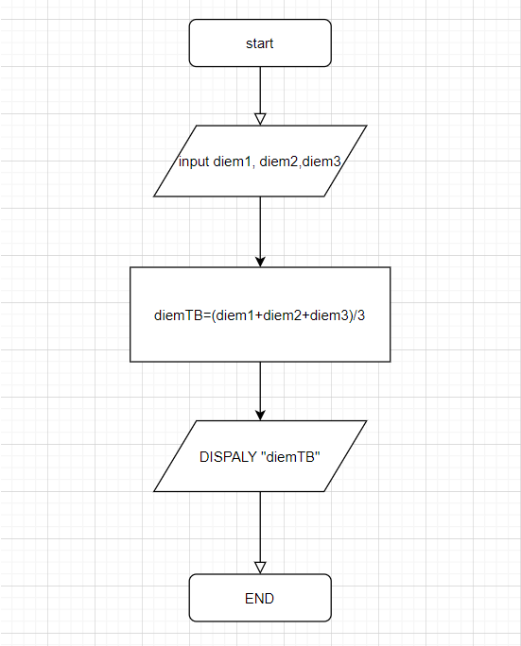

START

INPUT diemToan;

INPUT diemLy;

INPUT diemHoa;

diemTB = $\frac{diemToan+diemLy+diemHoa}{3}$

DISPLAY “diemTB”

END